SECTION A - WEBSITE PLANNING & DOCUMENTATION

**1. Website Specifications**

**[a].**

Warner Bros Mission Statement:

Is to make a positive impact on the world through initiatives that encourage youth to be storytellers, create access and opportunities for new voices, and drive sustainable production. **(Mission Statement Academy 2023).**

This mission statement must be evident in the warner bros website as well. This is because whatever information regarding businesses, especially ones as large as this one, can and should be found online for user convenience. Consequently, by reaching out to people online through a website, we must cater to a large audience with varying interests. An example would be parents going to the site to find a movie or TV series that’s child friendly. How do we present this content? Would it be done the same way as content catered to people over the age of 18?

After taking this into consideration, the website should cater to the various kinds of people. In a universal sense. When the goal of the website is to provide an indiscriminatory service, we absolutely must present the content in a straightforward and accessible format.

**[b].**

Therefore the Segmentation of the company is from movies, television shows and superhero series. The target market follows young teens, young adults and kids on the basis of genre. The positioning of Warner Bros is the Franchising of films using a fully digital supply chain. **(Aditya Shastri 2022).**

As stated above, Warner Bros leans more towards serving the younger demographic of the population. These are further broken down into other demographics such as gender so as it really caters to as many individuals as possible. Targeting the younger demographic is both advantageous and disadvantageous. Its advantageous in the sense that younger people tend to be a lot more computer literate when compared to other age groups. However, they also tend to be a bit more sensitive so being careful of what is put on the site is important.

Kids although computer literate, they are only able to digest small and very simple content. A lot of colours, images, and moving pictures tends to be more to their liking. We could say that they have a next to basic technical aptitude. Both the male and female members of this target are more into animated pieces, that more often than not contain music and other media they can easily follow along

Teenagers are exceptionally computer literate. So, content must be apprehensive and eye catching whilst also not being too childlike. It’s a more difficult audience to cater to since they are going through a transitional process in their lives. Majority of them have an intermediate level of technical aptitude. The male demographic tends to lean towards superhero content or media with a lot of thrill and action. The female demographic on the other hand leans towards simple and more grounded/ realistic content that focus on real life settings.

Young adults are more mature and by now are much more comfortable with technology. They’re interested in more mature content and just want their content given to them straightforward but user-friendly way that does not waste their time. If they have been using technology for a good portion of their lives, they should have a higher technological aptitude than the other members of the target audience. the demographics become trickier as this stage in their life, they are just more interested in watching whatever tickles their fancy regardless of genre. So with this kind of setting, the content should be presented in a more unisex sort of way.

**[c].**

 Before we even get to the creation of the website, I must first decide what kind of website or more importantly, what kind of content I’d like to offer people interested in the site. It’s important that I don’t stray too far away from what Warner Bros is a whole. Allow me to reiterate what warner bros is and what they have achieved and will continue to achieve:

A Warner Bros. Discovery company, the Studio is home to one of the most successful collections of brands in the world and stands at the forefront of every aspect of the entertainment industry, from feature film, television, digital and home entertainment production and worldwide distribution to DVD and Blu-ray, animation, comic books, videogames, and product and brand licensing. (**Warner Bros).**

I drafted a short list of that users what might to see on the website and in the end, I finally came to the following conclusion:

* Movies and TV series that are coming soon.
* Popular movies and TV shows.
* New movies and TV shows.
* The different apps and games warner bros offers.
* Latest news regarding everything warner bros.
* Search functionality.
* Feedback forum.

The entire website’s content will revolve around these factors and display them in a way that’s very accessible to a user without any sort of delay.

**2. Information Design & Taxonomy**

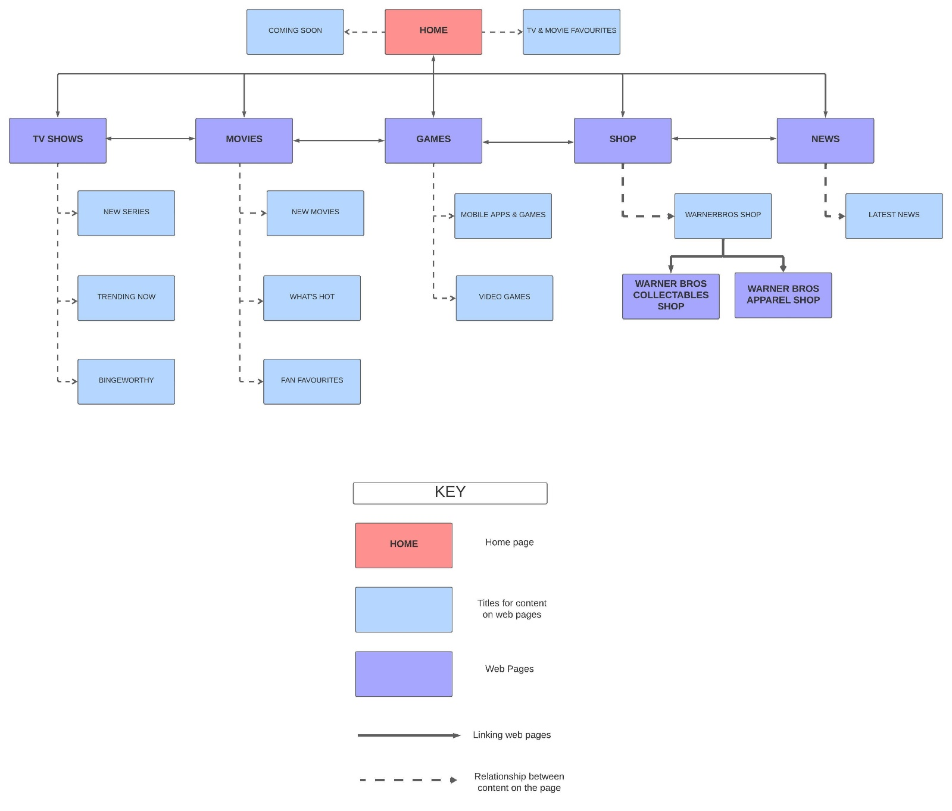

**3. Page Template Design**

***Home Page:***

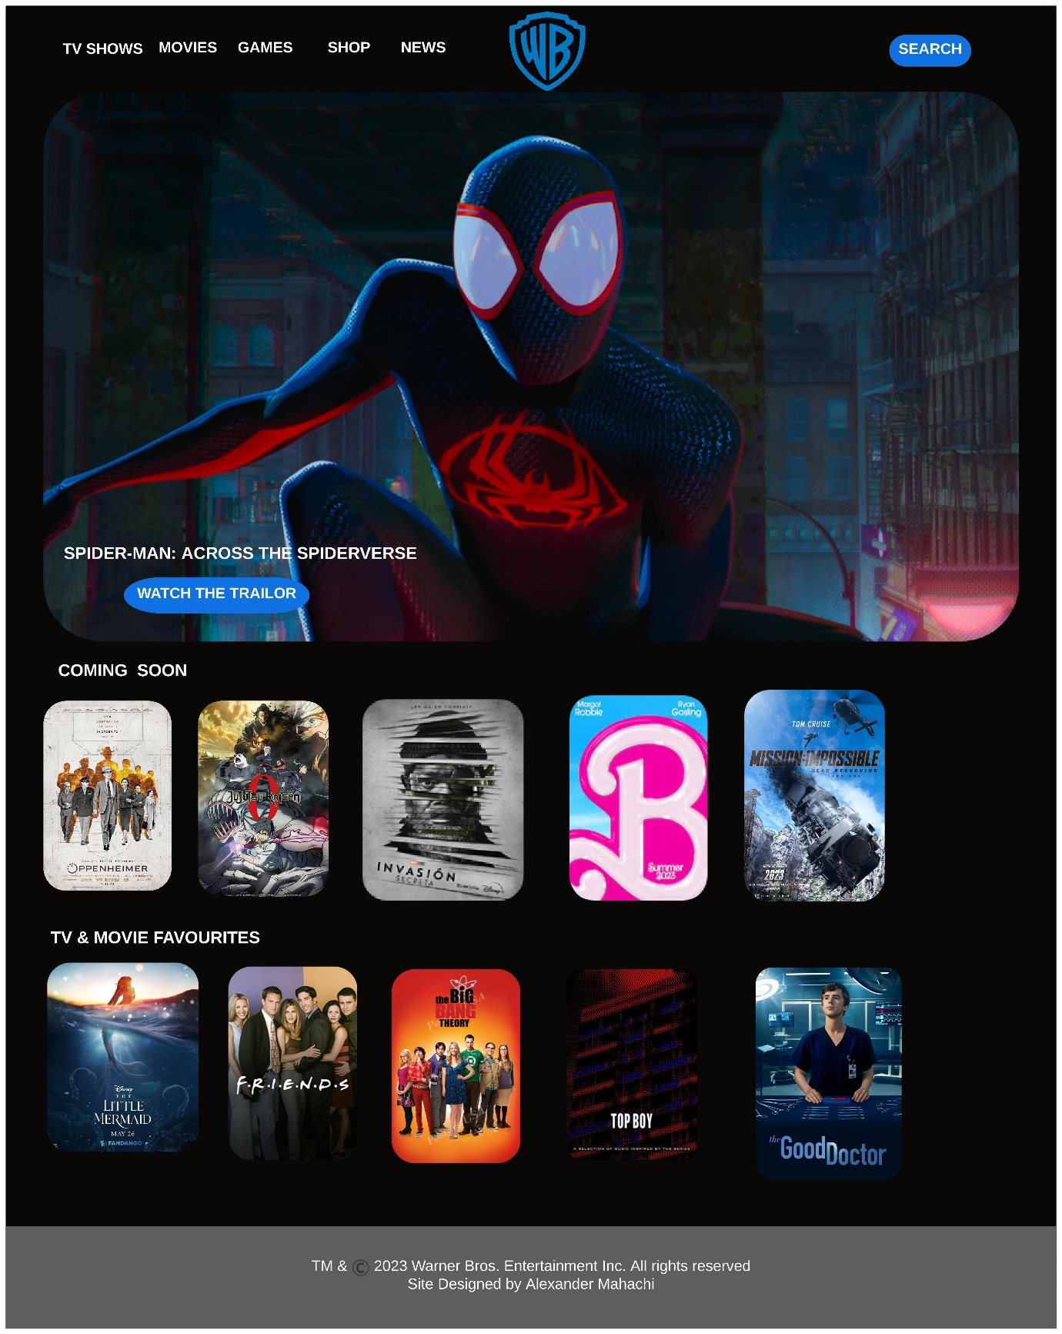

***TV Shows Page:***

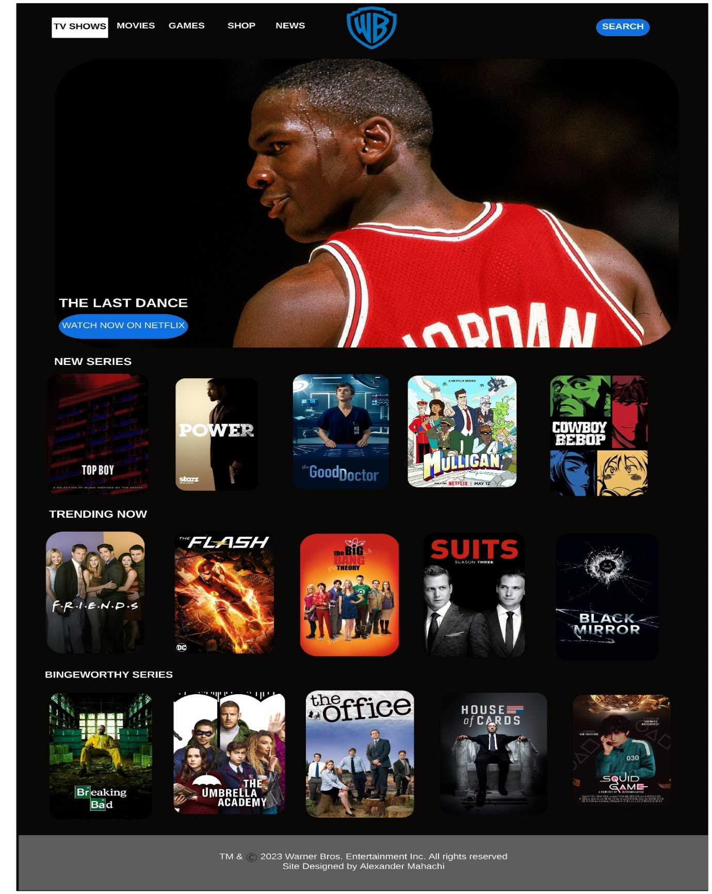

***Movies Page:***

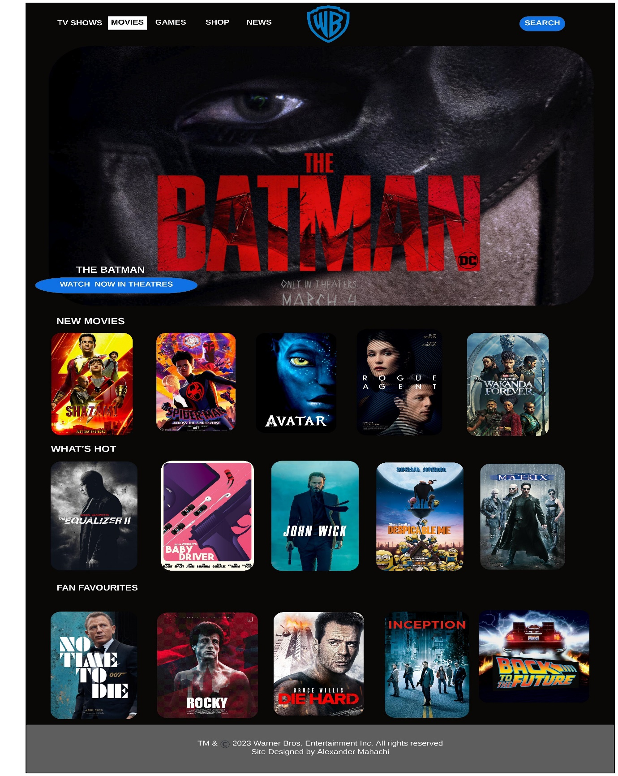

***Games Page:***

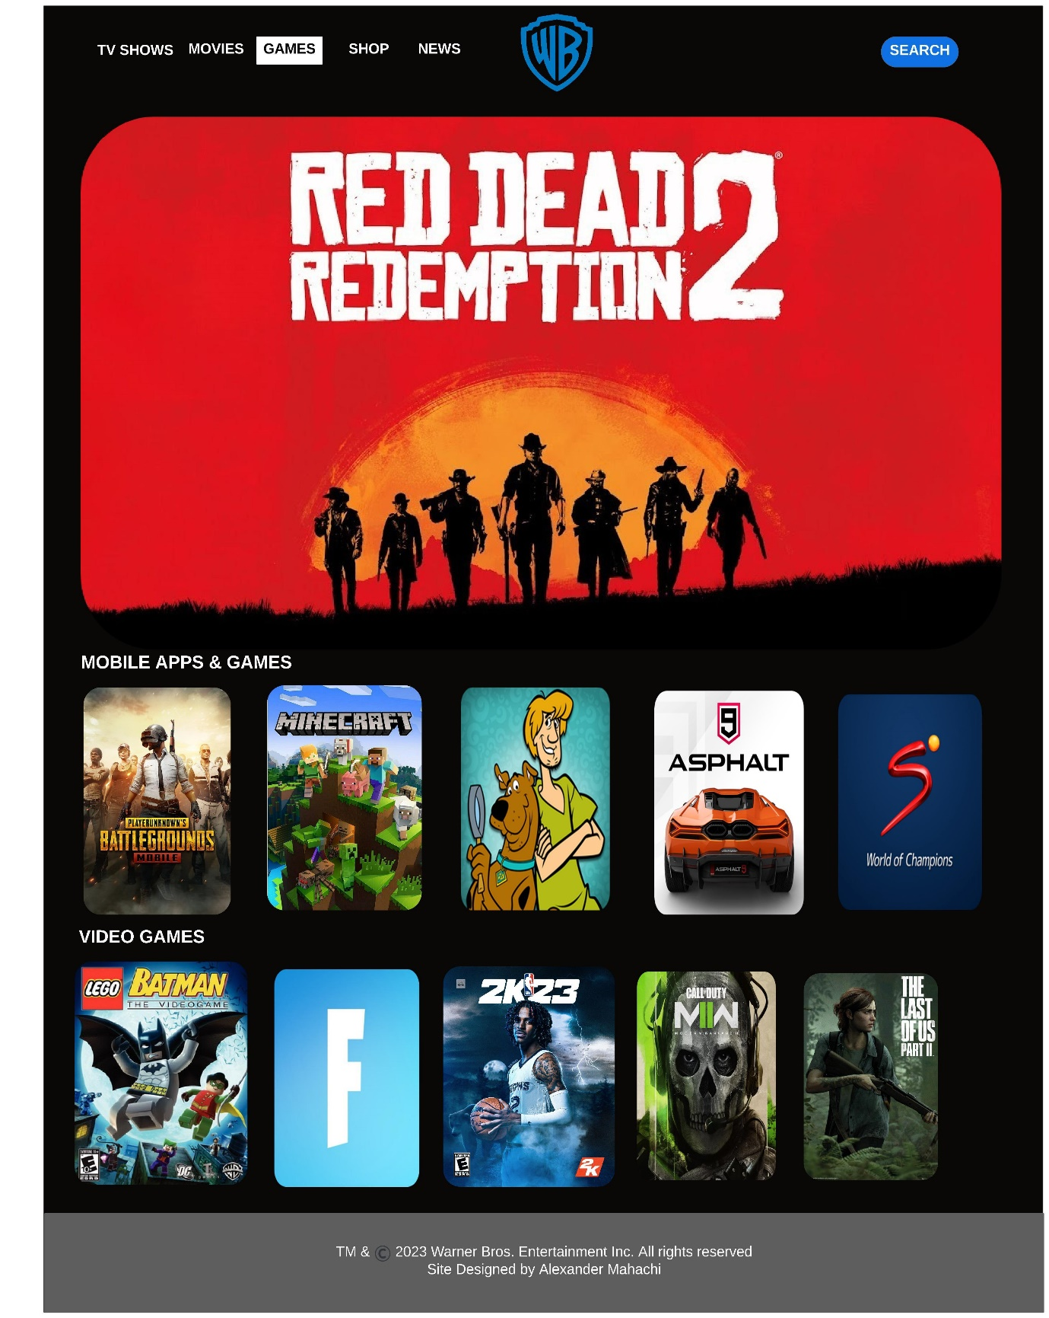

***Shop page:***

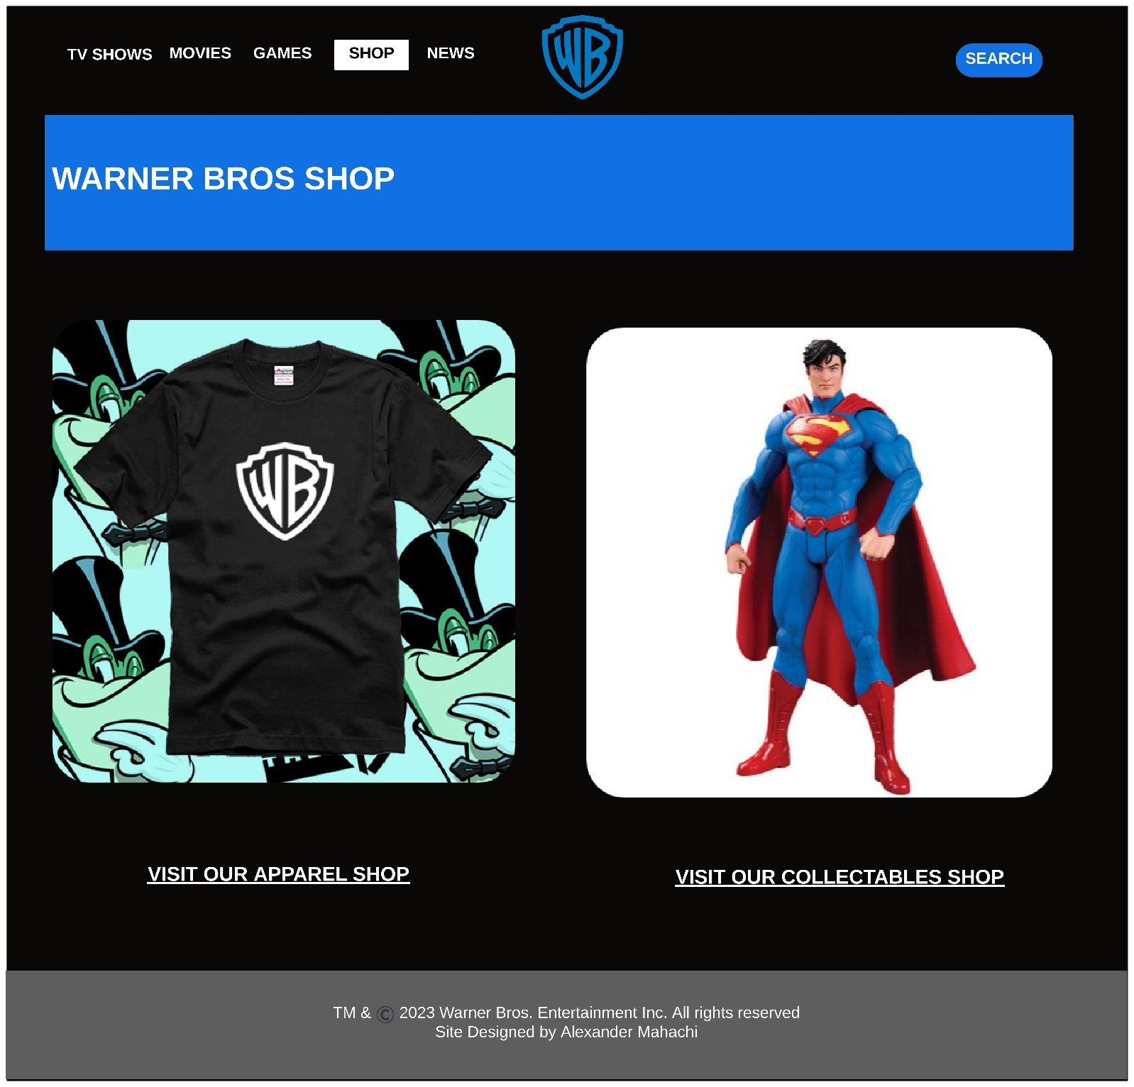

***News Page:***

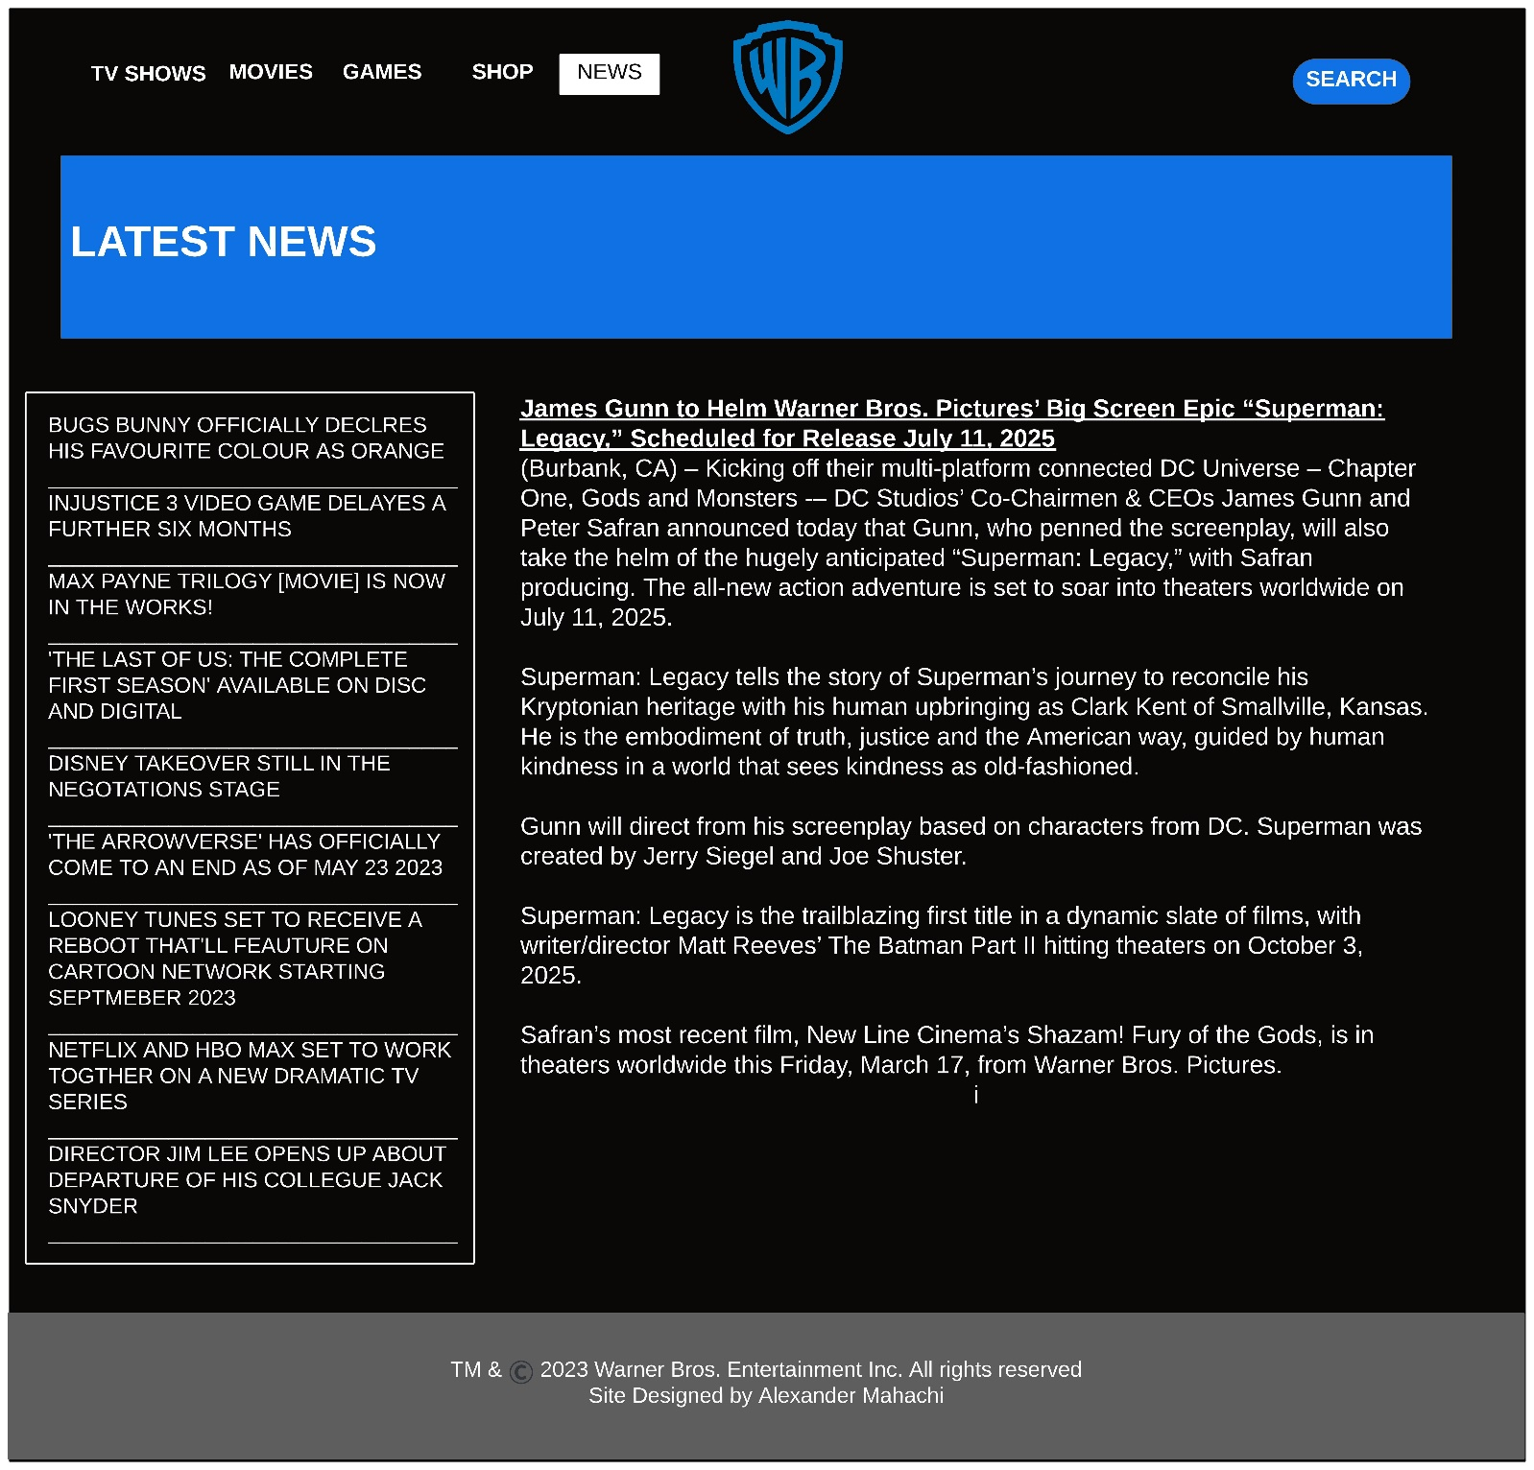

**4. Technical Brief**

In this technical brief, I’ll be detailing all the resources I used to make this website possible. They’re as follows:

1. Lucidspark – This is the online resource that I used to create my wireframes. This application is also helpful with other diagrams including the site map. Its fast and generally user friendly. I opted for this one instead of wireframes.io from that get go as this has always been my to go diagramming tool. I also used the application to create my site map.
2. <https://round-corner.imageonline.co/> is the website I used to round the corners of the images I put into my wireframe. I used appropriate CSS on the actual website to round the corners of my images. Though lucid spark is fantastic, it’s doesn’t offer such functionality. I stored the images with rounded corners into their own folder alongside the complete wireframes
3. I made us of VS Code as my main text editor for HTML and CSS coding. I started out with notepad++ but I released halfway through that i wouldn’t be done with the assignment in time. VS Studio code is incredible, and I plan on making it my full-time text editor.
4. Use of github, and gitbash for the creation of gitpages. I ran into a lot of problems which forced me to create many repositories. Unfortunately, I still was not able to get the page to function even after saving all related files in lower case letters.

**5. Quality Assurance**

*Browser Tests*

For the browser tests, I will be taking a screenshot of the home page only!

1. ***Google Chrome***

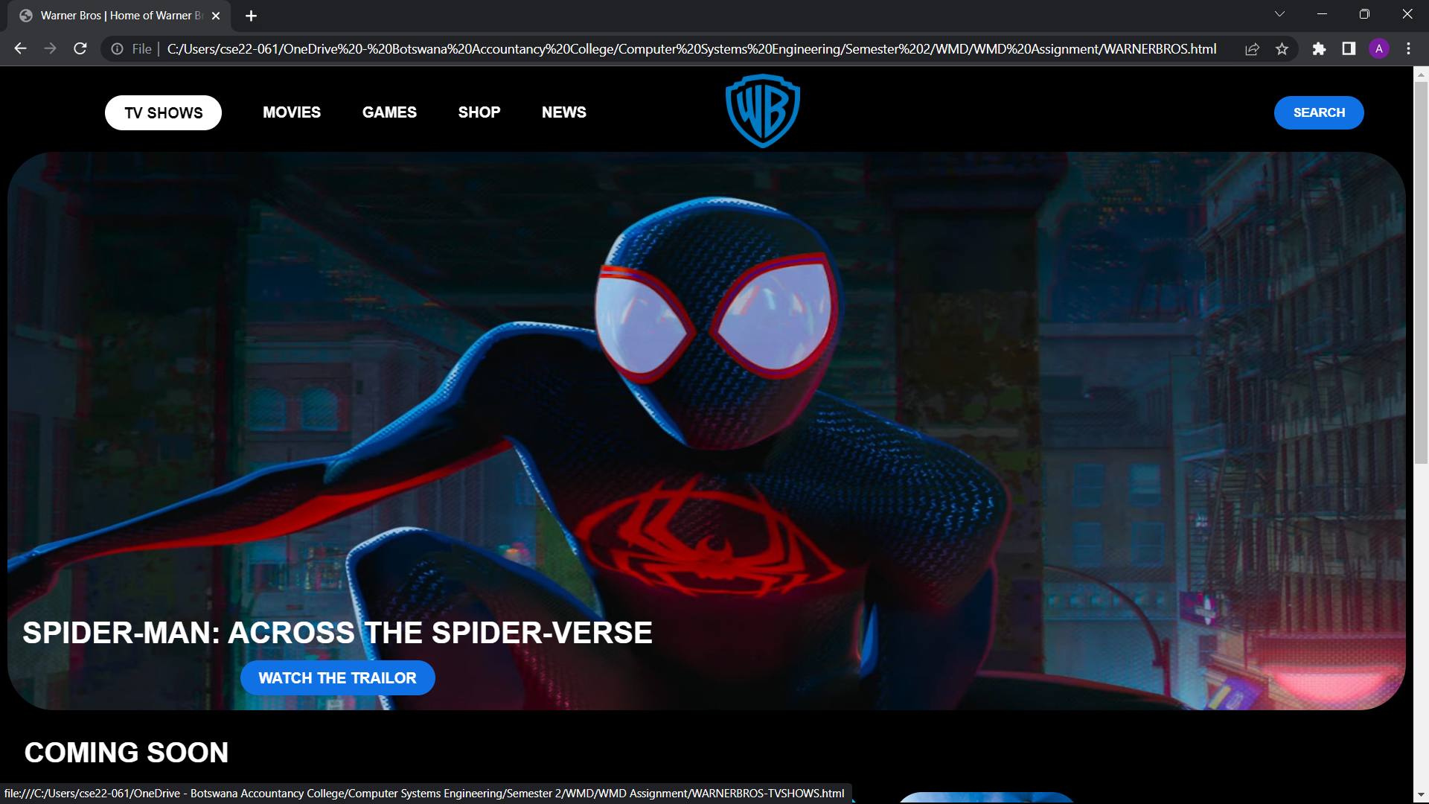

*With chrome it appears exactly the way that I imagined. The issue I failed to address was the way the website would look while the window size is reduced. Have a look:*

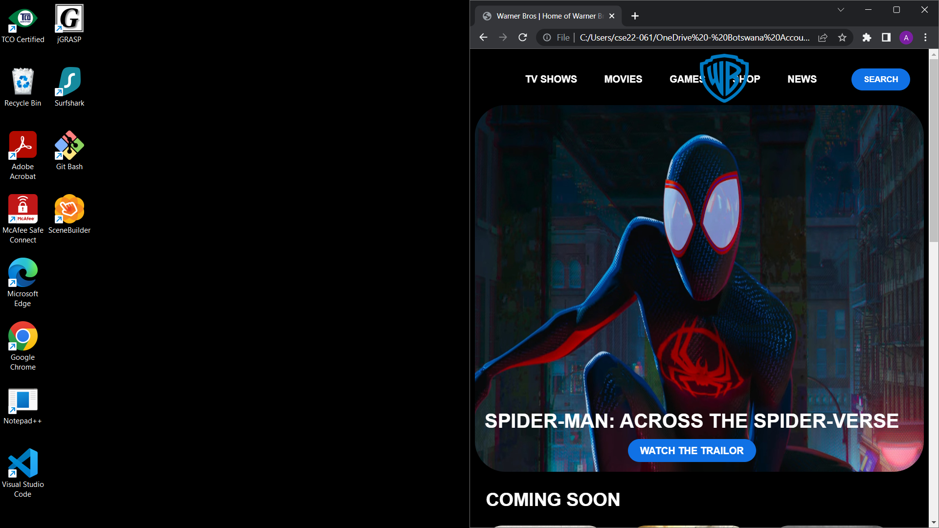

1. ***Microsoft edge***

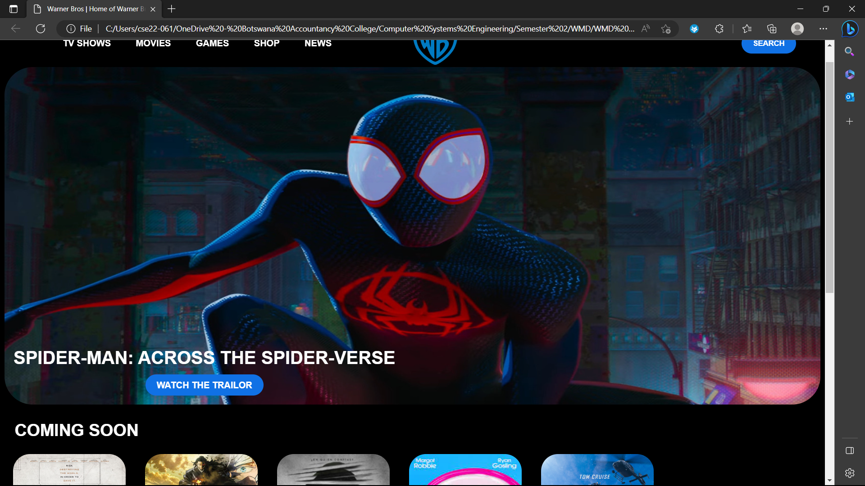

*Microsoft Edge also rendered the web page properly. Again, it’s appearance when the window is minimized is a bit shoddy. Have a look:*

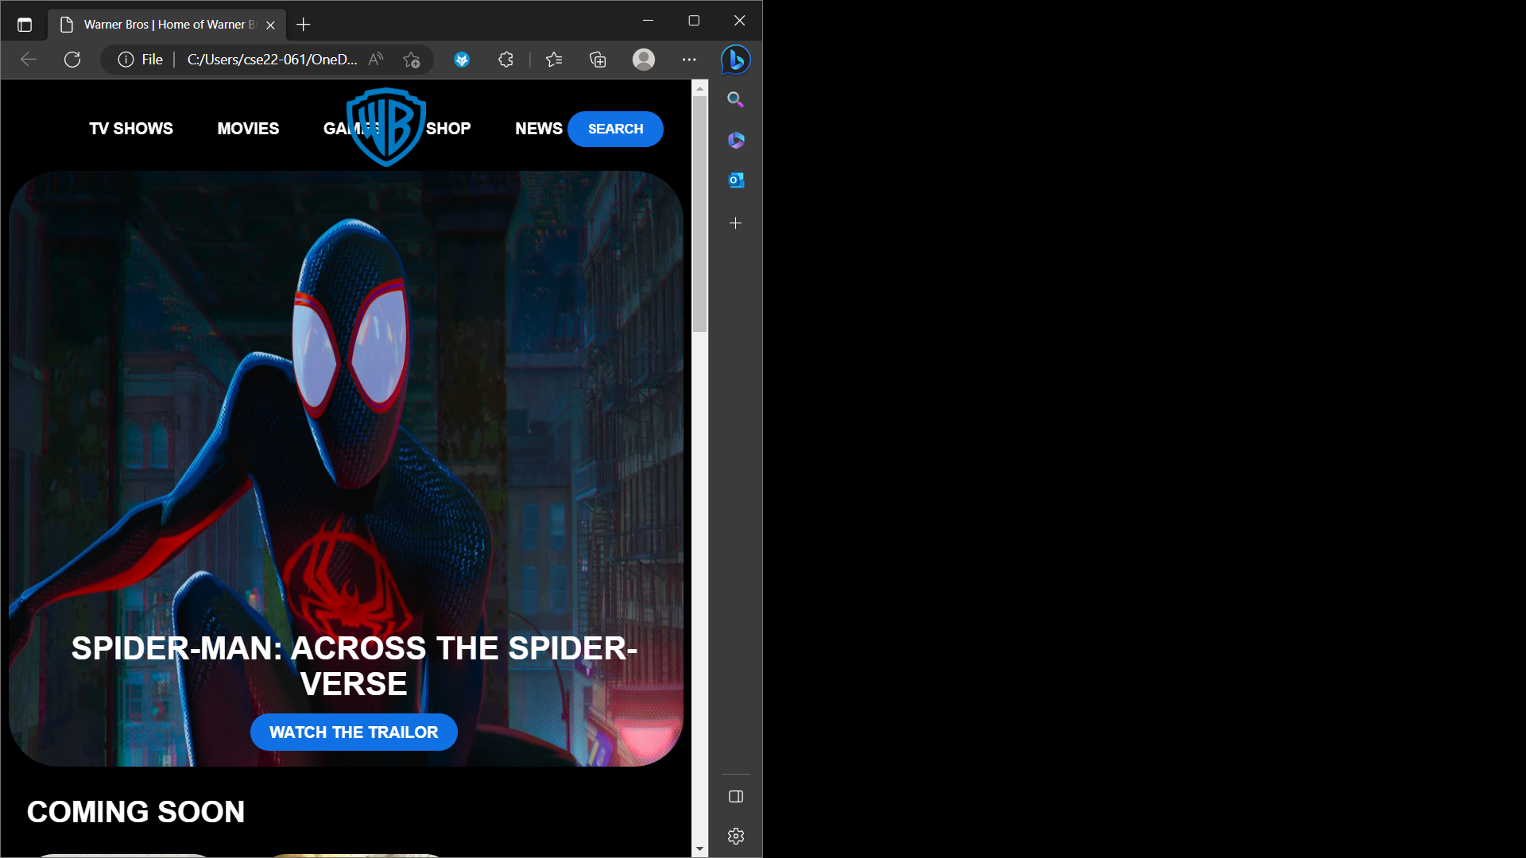

1. ***Mozilla Firefox***

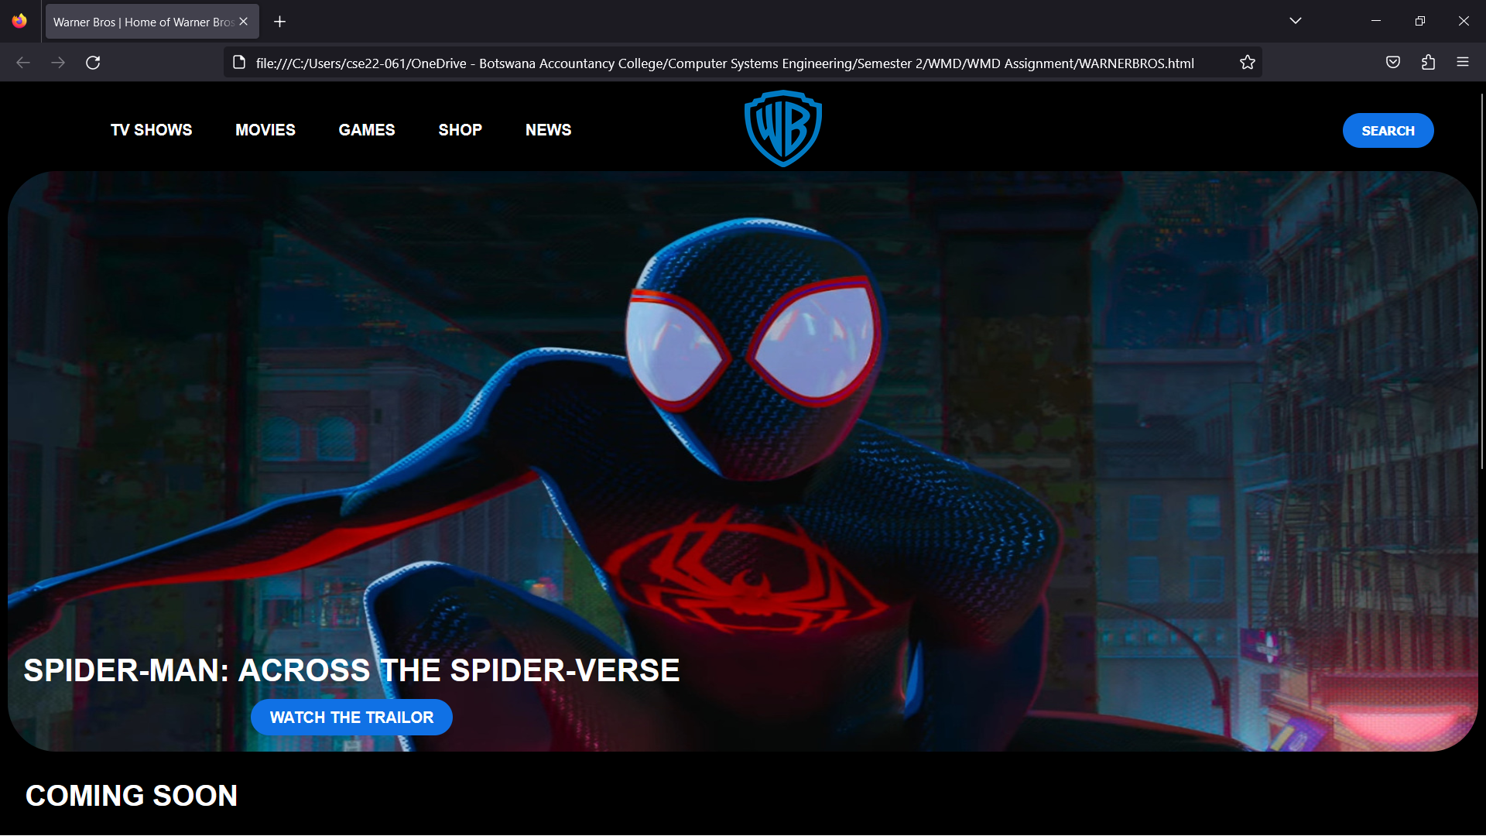

*It performs similarly to google chrome and Microsoft edge. I might even prefer it loading into the web browser. But it still has the same resizing issue:*

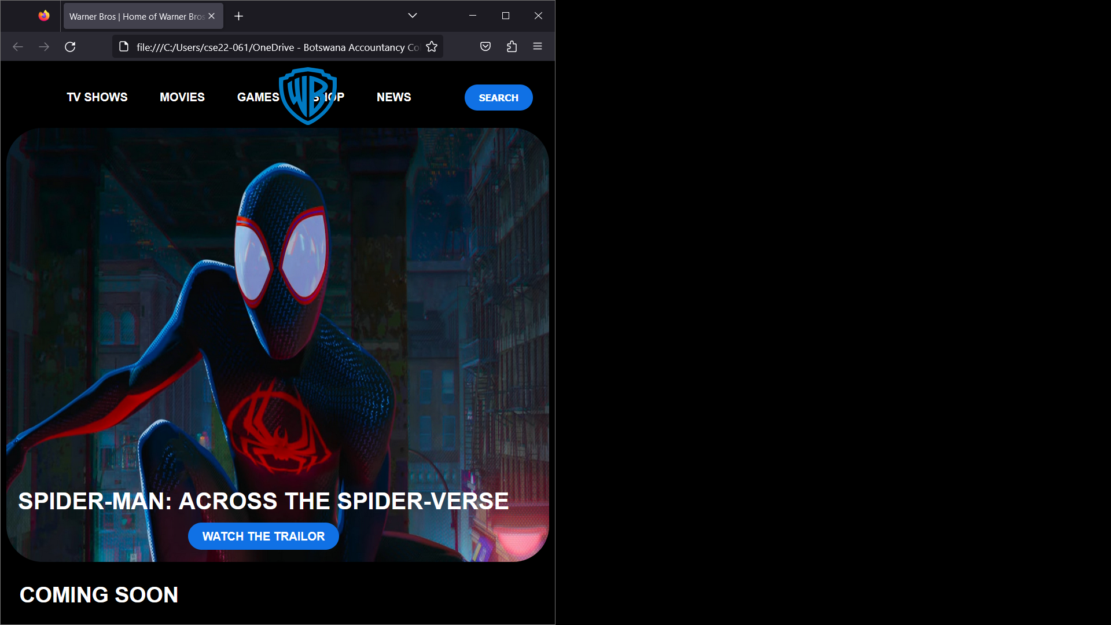

**6. Publishing & Promotion**

**7. Future developments/Recommendations**

In the future, I could turn all the images in their respective containers into hyperlinks. This way I can provide further information on specific content. An example would be a user clicking on an image in the new series section and taking them to a page that gives the necessary information regarding that page without providing any spoilers. I could even go as far as letting a trailer for whatever it is a user is hovering over and playing a trailer for that specific content.

I could also create new page that would be used to collect user feedback. All feedback, good and bad, is necessary to keep the website as straightforward and useable as possible. Users would type in their first and last names and proceed to fill out the text field about whatever it is they feel like they need us to know.

Lastly, I could create and dedicate a whole new page to the history of Warner Bros, along with its goals and aspirations. This page gives users an understanding of what exactly it took to get Warner Bros this far as well as the direction they’re currently headed in. it could contain clever little slideshows and videos that are easy to digest.

**REFERENCE LIST**

Mission Statement Academy. 2023. *Warner Brothers Mission Statement.*[Online] Available from: <https://mission-statement.com/warner-brothers-mission/> .[Accessed Date: 26 May 2023].

Aditya Shastri. 2022. Detailed Marketing Strategy of Warner Bros with Company Overview. *Marketing Strategy of Warner Bros: Segmentation, Targeting, and Positioning.* Available from: <https://iide.co/case-studies/marketing-strategy-of-warner-bros/#:~:text=Therefore%20the%20Segmentation%20of%20the,a%20fully%20digital%20supply%20chain>. [Accessed Date: 26 May 2023].

Warner Bros. *Company Overview*.[Online]. Available from: <https://www.warnerbros.com/studio/about/company-overview> .[Accessed Date: 26 May 2023]